Model calibration involved adjustments to the bathymetry of the Itaipu and Camboatá Channels, as well as to the river inflow rates applied in the simulations. The available river discharges, obtained from HYDROSCIENCE (2018), corresponded to annual mean values and therefore may not fully represent the hydrological conditions observed during the simulated period. In addition, the morphology of tidal inlets in the study area is highly dynamic, responding continuously to variations in wave-induced longshore sediment transport, tidal forcing, and freshwater inflows. Consequently, adjustments to the bottom geometry of the Itaipu Channel were necessary to obtain a hydrodynamic configuration more representative of the analyzed period. Similarly, modifications to the Camboatá Channel bathymetry were required due to limitations in the available morphological data for this region.
Figure 6 compares the measured water levels inside the Piratininga Lagoon with the corresponding model results obtained for the Reference Scenario (RS) after calibration. A strong agreement between observed and simulated water levels was achieved, indicating that the model adequately reproduced the hydrodynamic response of the lagoon under the prevailing environmental conditions. Figure 7 presents the comparison between measured and simulated water levels in the Itaipu Lagoon. Although the overall agreement remained satisfactory, slight phase displacements between the time series were observed during specific periods.
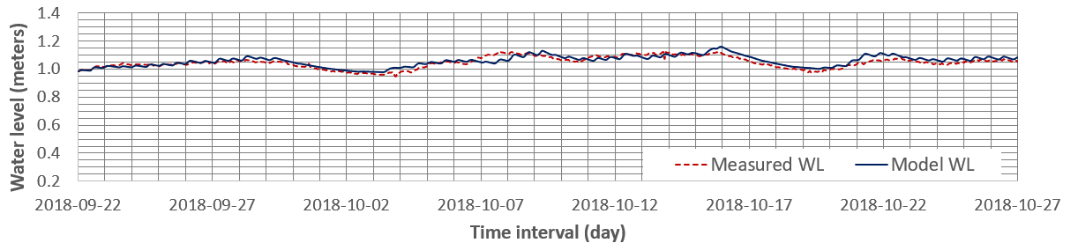
Figure 6 - Comparison between measured water level and model result, after calibration, for the Piratininga Lagoon. Reference Level: Nautical Chart 1511 Datum - DHN.
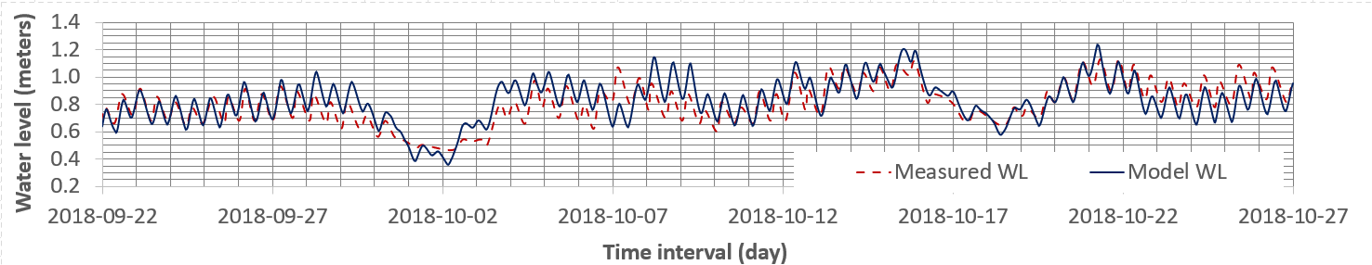
Figure 7 - Comparison between measured water level and model result for the Itaipu Lagoon, validating the calibration procedure. Reference Level: Nautical Chart 1511 Datum - DHN.
These differences are likely associated with short-term morphological variability in the Itaipu Channel, whose geometry can change rapidly in response to sediment transport and hydrodynamic forcing. Since the adopted hydrodynamic simulations considered fixed bottom geometry, transient morphological changes occurring during the monitoring period were not represented in the model. Nevertheless, the simulations provided a consistent qualitative representation of the water level oscillations and tidal propagation within the lagoon system.
The Reference Scenario (RS), adopted for calibration and validation procedures, reproduced the environmental conditions observed between 22 September and 27 October 2018. During this period, the Tibau Tunnel remained unobstructed, maintaining direct hydraulic connectivity between the Piratininga Lagoon and the ocean. In contrast, both the Itaipu and Camboatá Channels presented significant siltation levels, partially restricting water exchange processes between the lagoons and the adjacent marine environment.

